

Life Insurence BUSINESS

REPORT

Project Report

Contents

**1 Introduction to Business Problem 3**

1.1 Defining the problem statement 3

1.2 Need Of the Study/Project 3

1.3 Understanding Business Opurtunity 3

**2: Data Report** 3

2.1 Understanding how data was collected in terms of time, frequency and methodology 3

2.2 Visual inspection of data (rows, columns, descriptive details) 4

2.3 Understanding of attributes (variable info, renaming if required) 6

**3. Expliratory Data Analysis** 10

3.1 Univariate analysis (distribution and spread for every continuous attribute, distribution of data in categories for categorical ones) 10

3.2 Bivariate analysis (relationship between different variables , correlations) 12

3.3 Removal of unwanted variables (if applicable) 14

3.4 Missing Value treatment (if applicable) 14

3.5 Outlier treatment (if required) 15

3.6 Variable transformation (if applicable) 18

3.7 Addition of new variables (if required) 20

**4. Business Insights from EDA** 20

4.1 Is the data unbalanced? If so, what can be done? Please explain in the context of the business 20

4.2 Any business insights using clustering (if applicable) 20

4.3 Any other business insights 23

# Introduction to Business Problem

## Defining the problem statement

The dataset belongs to a leading life insurance company. The company wants to

predict the bonus for its agents so that it may design appropriate engagement activity

for their high performing agents and upskill programs for low performing agents.

## Need Of the Study/Project

As we know the company wants to get a knowledge about the performance of

it’s agent, so that effective upskill programme can be arranged for low performing agents

and various engagement activities for high performers. This study will therefore help the low

Performers to enhance their skills and inturn helps the company have more efficient agents.

Similarly the study will help the high performers to know about where they can improve more.

Overall this study is very essential for the company to boost it’s performence.

## Understanding Business Opurtunity

1. Company can understand the market perspective.
2. Company will identify the high value agents and low value agents
3. Company will accordingly plan the upskill program and also able to give reward to

high value agents

iv)company will understand who will be the target value customer

# 2: Data Report

## Understanding how data was collected in terms of time, frequency and methodology

The dataset is devided quite evenly among high performers and low performers but the zone wise representation is

High for west and north zone while compared to others.

|  |  |
| --- | --- |
| **Variable** | **Discerption** |
| CustID | Unique customer ID |
| AgentBonus | Bonus amount given to each agents in last month |
| Age | Age of customer |
| CustTenure | Tenure of customer in organization |
| Channel | Channel through which acquisition of customer is done |
| Occupation | Occupation of customer |
| EducationField | Field of education of customer |
| Gender | Gender of customer |
| ExistingProdType | Existing product type of customer |
| Designation | Designation of customer in their organization |
| NumberOfPolicy | Total number of existing policy of a customer |
| MaritalStatus | Marital status of customer |
| MonthlyIncome | Gross monthly income of customer |
| Complaint | Indicator of complaint registered in last one month by customer |
| ExistingPolicyTenure | Max tenure in all existing policies of customer |
| SumAssured | Max of sum assured in all existing policies of customer |
| Zone | Customer belongs to which zone in India. Like East, West, North and South |
| PaymentMethod | Frequency of payment selected by customer like Monthly, quarterly, half yearly and yearly |
| LastMonthCalls | Total calls attempted by company to a customer for cross sell |
| CustCareScore | Customer satisfaction score given by customer in previous service call |

## Visual inspection of data (rows, columns, descriptive details)

# Column Non-Null Count Dtype

--- ------ -------------- -----

0 CustID 4520 non-null int64

1 AgentBonus 4520 non-null int64

2 Age 4251 non-null float64

3 CustTenure 4294 non-null float64

4 Channel 4520 non-null object

5 Occupation 4520 non-null object

6 EducationField 4520 non-null object

7 Gender 4520 non-null object

8 ExistingProdType 4520 non-null int64

9 Designation 4520 non-null object

10 NumberOfPolicy 4475 non-null float64

11 MaritalStatus 4520 non-null object

12 MonthlyIncome 4284 non-null float64

13 Complaint 4520 non-null int64

14 ExistingPolicyTenure 4336 non-null float64

15 SumAssured 4366 non-null float64

16 Zone 4520 non-null object

17 PaymentMethod 4520 non-null object

18 LastMonthCalls 4520 non-null int64

19 CustCareScore 4468 non-null float64

dtypes: float64(7), int64(5), object(8)

memory usage: 706.4+ KB

|  |  |  |  |  |  |  |  |  |  |  |  |
| --- | --- | --- | --- | --- | --- | --- | --- | --- | --- | --- | --- |
|  | **count** | **unique** | **top** | **freq** | **mean** | **std** | **min** | **25%** | **50%** | **75%** | **max** |
| **AgentBonus** | 4520.00 | NaN | NaN | NaN | 4077.84 | 1403.32 | 1605.00 | 3027.75 | 3911.50 | 4867.25 | 9608.00 |
| **Age** | 4520.00 | NaN | NaN | NaN | 14.41 | 8.77 | 2.00 | 8.00 | 13.00 | 19.00 | 58.00 |
| **CustTenure** | 4520.00 | NaN | NaN | NaN | 14.40 | 8.74 | 2.00 | 8.00 | 13.00 | 19.00 | 57.00 |
| **Channel** | 4520 | 3 | Agent | 3194 | NaN | NaN | NaN | NaN | NaN | NaN | NaN |
| **Occupation** | 4520 | 4 | Salaried | 2192 | NaN | NaN | NaN | NaN | NaN | NaN | NaN |
| **EducationField** | 4520 | 6 | Graduate | 1870 | NaN | NaN | NaN | NaN | NaN | NaN | NaN |
| **Gender** | 4520 | 2 | Male | 2688 | NaN | NaN | NaN | NaN | NaN | NaN | NaN |
| **ExistingProdType** | 4520.00 | NaN | NaN | NaN | 3.69 | 1.02 | 1.00 | 3.00 | 4.00 | 4.00 | 6.00 |
| **Designation** | 4520 | 5 | Executive | 1662 | NaN | NaN | NaN | NaN | NaN | NaN | NaN |
| **NumberOfPolicy** | 4520.00 | NaN | NaN | NaN | 3.57 | 1.45 | 1.00 | 2.00 | 4.00 | 5.00 | 6.00 |
| **MaritalStatus** | 4520 | 4 | Married | 2268 | NaN | NaN | NaN | NaN | NaN | NaN | NaN |
| **MonthlyIncome** | 4520.00 | NaN | NaN | NaN | 22823.25 | 4764.89 | 16009.00 | 19858.00 | 21606.00 | 24531.75 | 38456.00 |
| **Complaint** | 4520.00 | 2.00 | 0.00 | 3222.00 | NaN | NaN | NaN | NaN | NaN | NaN | NaN |
| **ExistingPolicyTenure** | 4520.00 | NaN | NaN | NaN | 4.08 | 3.29 | 1.00 | 2.00 | 3.00 | 5.00 | 25.00 |
| **SumAssured** | 4520.00 | NaN | NaN | NaN | 618602.01 | 242117.25 | 168536.00 | 444476.25 | 578976.50 | 750010.50 | 1838496.00 |
| **Zone** | 4520 | 4 | West | 2566 | NaN | NaN | NaN | NaN | NaN | NaN | NaN |
| **PaymentMethod** | 4520 | 4 | Half Yearly | 2656 | NaN | NaN | NaN | NaN | NaN | NaN | NaN |
| **LastMonthCalls** | 4520.00 | NaN | NaN | NaN | 4.63 | 3.62 | 0.00 | 2.00 | 3.00 | 8.00 | 18.00 |
| **CustCareScore** | 4520.00 | NaN | NaN | NaN | 3.07 | 1.38 | 1.00 | 2.00 | 3.00 | 4.00 | 5.00 |
| **Result** | 4520 | 2 | low | 2474 | NaN | NaN | NaN | NaN | NaN | NaN | NaN |

## Understanding of attributes (variable info, renaming if required)

|  |  |  |  |  |
| --- | --- | --- | --- | --- |
| ***#*** | ***Column*** | ***Count*** | ***Dtype*** | ***Remark*** |
| *0* | *CustID* | *4520* | *int64* | *Dropped as not important.* |
| *1* | *AgentBonus* | *4520* | *int64* | *Numeric, target variable* |
| *2* | *Age* | *4251* | *float64* | *Numeric* |
| *3* | *CustTenure* | *4294* | *float64* | *Numeric* |
| *4* | *Channel* | *4520* | *object* | *Categorical* |
| *5* | *Occupation* | *4520* | *object* | *Categorical* |
| *6* | *EducationField* | *4520* | *object* | *Categorical* |
| *7* | *Gender* | *4520* | *object* | *Categorical* |
| *8* | *ExistingProdType* | *4520* | *int64* | *Numeric* |
| *9* | *Designation* | *4520* | *object* | *Categorical* |
| *10* | *NumberOfPolicy* | *4475* | *float64* | *Numeric* |
| *11* | *MaritalStatus* | *4520* | *object* | *Categorical* |
| *12* | *MonthlyIncome* | *4284* | *float64* | *Numeric* |
| *13* | *Complaint* | *4520* | *int64* | *Converted into categorical* |
| *14* | *ExistingPolicyTenure* | *4336* | *float64* | *Numeric* |
| *15* | *SumAssured* | *4366* | *float64* | *Numeric* |
| *16* | *Zone* | *4520* | *object* | *Categorical* |
| *17* | *PaymentMethod* | *4520* | *object* | *Categorical* |
| *18* | *LastMonthCalls* | *4520* | *int64* | *Numeric* |
| *19* | *CustCareScore* | *4468* | *float64* | *Numeric* |

Dropped Column CustID.

df.drop(['CustID'],axis=1,inplace=True)

The name of the columns seems to be fine with no special characters or spaces between them .

Unique values of various Categories

Channel : 3

Online 468

Third Party Partner 858

Agent 3194

Name: Channel, dtype: int64

Occupation : 5

Free Lancer 2

Laarge Business 153

Large Business 255

Small Business 1918

Salaried 2192

Name: Occupation, dtype: int64

EducationField : 7

MBA 74

UG 230

Post Graduate 252

Engineer 408

Diploma 496

Under Graduate 1190

Graduate 1870

Name: EducationField, dtype: int64

Gender : 3

Fe male 325

Female 1507

Male 2688

Name: Gender, dtype: int64

Designation : 6

Exe 127

VP 226

AVP 336

Senior Manager 676

Executive 1535

Manager 1620

Name: Designation, dtype: int64

MaritalStatus : 4

Unmarried 194

Divorced 804

Single 1254

Married 2268

Name: MaritalStatus, dtype: int64

Zone : 4

South 6

East 64

North 1884

West 2566

Name: Zone, dtype: int64

PaymentMethod : 4

Quarterly 76

Monthly 354

Yearly 1434

Half Yearly 2656

Name: PaymentMethod, dtype: int64

The highlighted data seems to be recorded incorrectly and required replacement and this was done to ensure the right categories are picked up by the model

Post f ixing of the data

Channel : 3

Online 468

Third Party Partner 858

Agent 3194

Name: Channel, dtype: int64

Occupation : 4

Free Lancer 2

Large Business 408

Small Business 1918

Salaried 2192

Name: Occupation, dtype: int64

EducationField : 6

MBA 74

Post Graduate 252

Engineer 408

Diploma 496

Under Graduate 1420

Graduate 1870

Name: EducationField, dtype: int64

Gender : 2

Female 1832

Male 2688

Name: Gender, dtype: int64

Designation : 5

VP 226

AVP 336

Senior Manager 676

Manager 1620

Executive 1662

Name: Designation, dtype: int64

MaritalStatus : 4

Unmarried 194

Divorced 804

Single 1254

Married 2268

Name: MaritalStatus, dtype: int64

Complaint : 2

1 1298

0 3222

Name: Complaint, dtype: int64

Zone : 4

South 6

East 64

North 1884

West 2566

Name: Zone, dtype: int64

PaymentMethod : 4

Quarterly 76

Monthly 354

Yearly 1434

Half Yearly 2656

Name: PaymentMethod, dtype: int64

The complaint column was actually catagorical columns but perceived as numarical because of incorrect data capture .. Fixing the inconsistencies f ixed the type of the variable as well.

# Expliratory Data Analysis

## Univariate analysis (distribution and spread for every continuous attribute, distribution of data in categories for categorical ones)

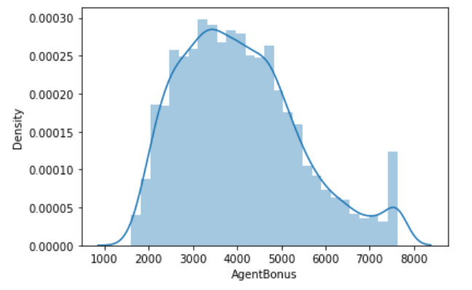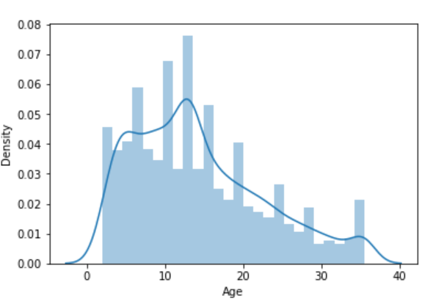

Continuous in a range

Continuous and Right Skewed

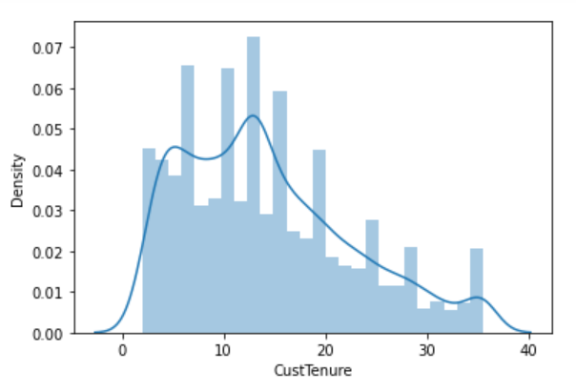 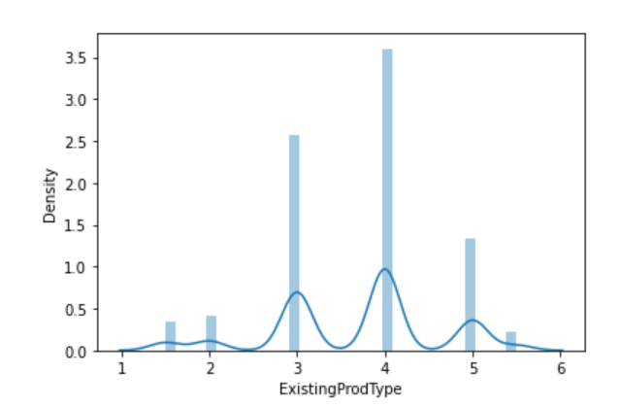

Discrete values with 4 most frequent

Right Skewed

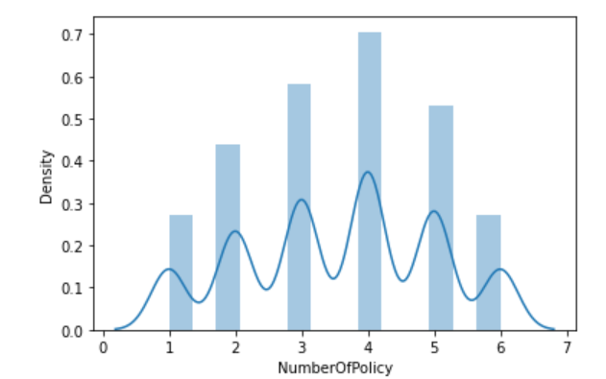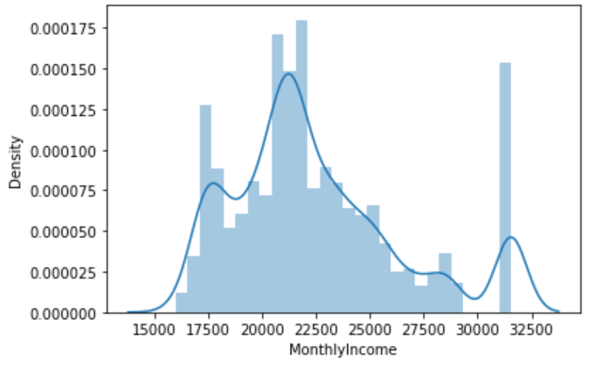

Continuous with some peaks

Discrete values with 4 most frequent

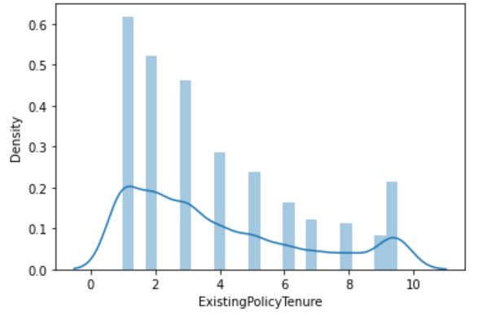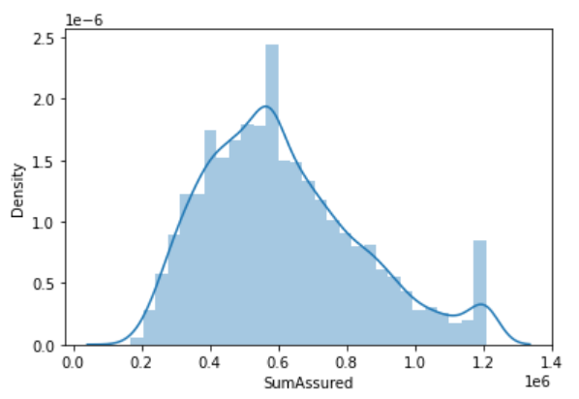

Continuous

Discrete with 0-2 range highest

## Bivariate analysis (relationship between different variables , correlations)

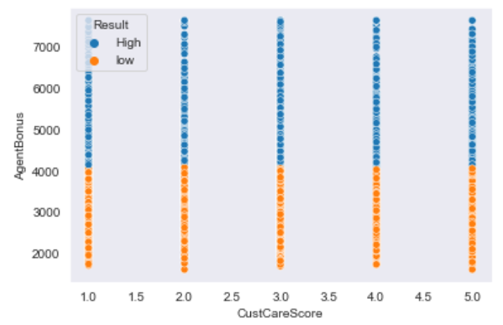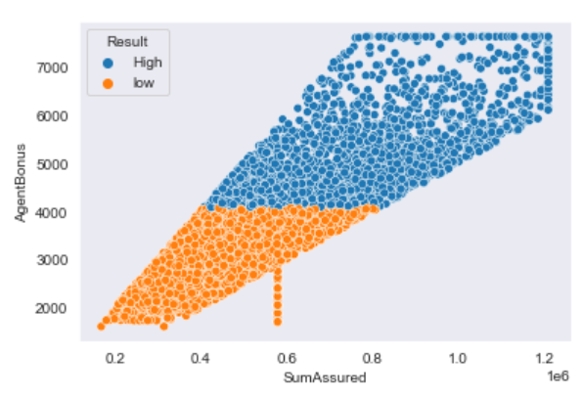

Positive Correlation

No relation found

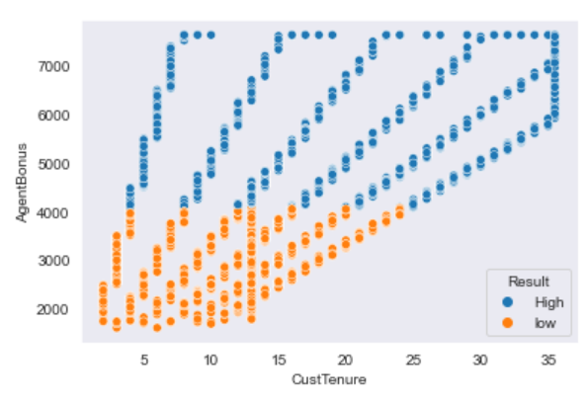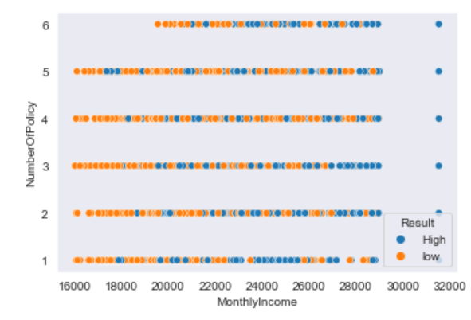

No relation found.

Positive Correlation

Most of the variables don’t seem to be related closely to each other which means there is low multi -collinearity in the data and each feature would have its importance in building the right model . because of this we have not dropped any columns other than CustId and would want to build the model to see the variable importance.

The pair plot also seems to suggest the same thing . But due to the huge number of columns pair plot was not providing very clear insight and hence resorted to bi variate plots with every combination possible.

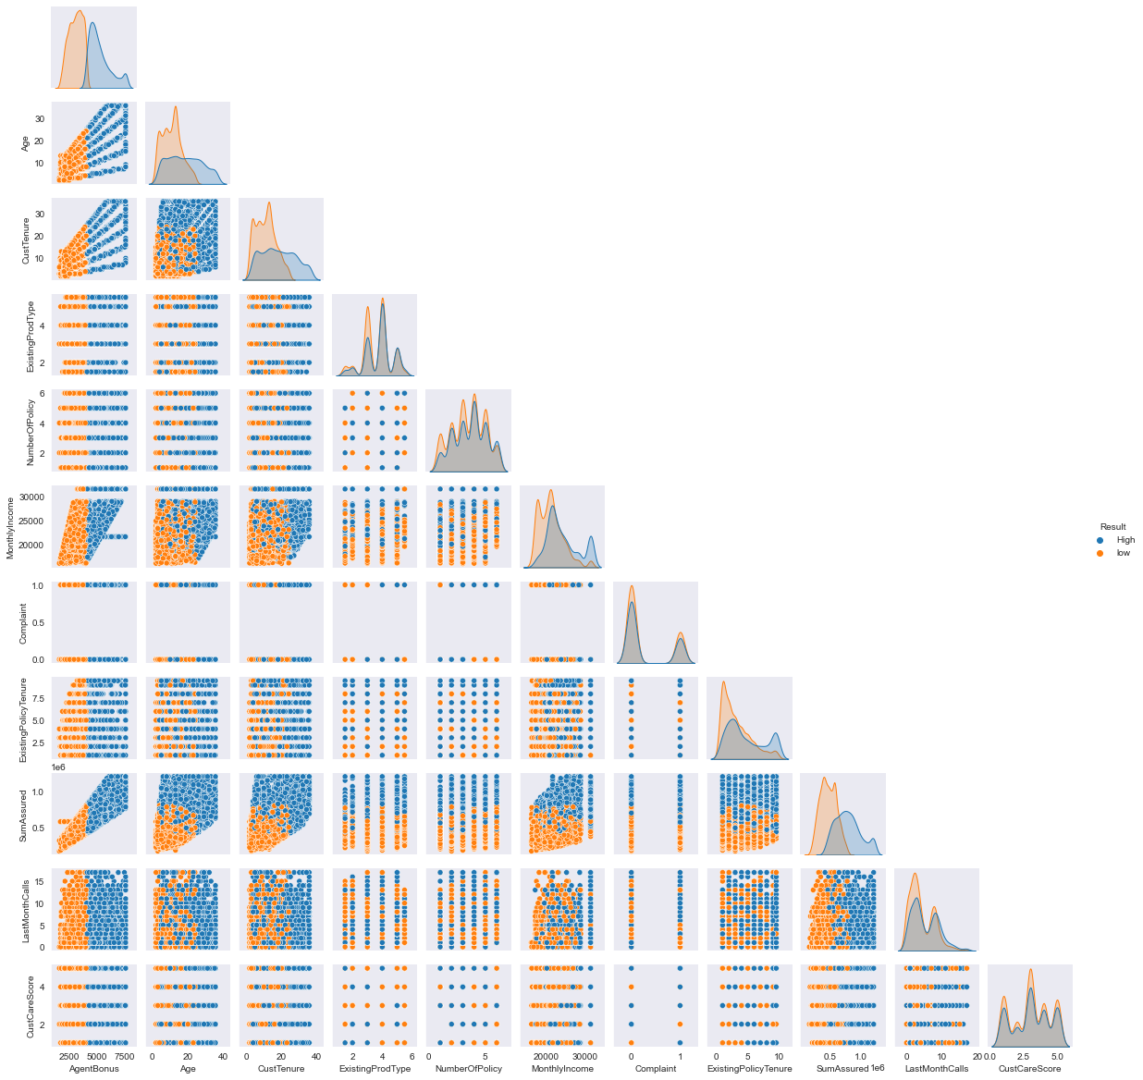

## Removal of unwanted variables (if applicable)

CustID is a redundant column and has been removed. Chose not to remove any other columns and lef t to the model phase where the variable importance would be judged.



## Missing Value treatment (if applicable)

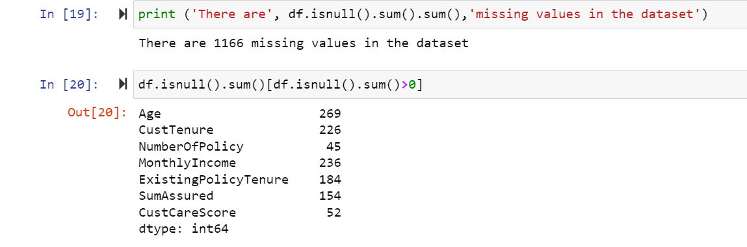

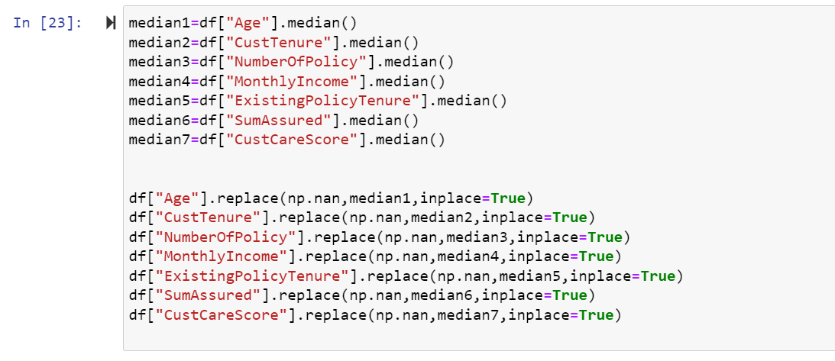

Since all the varriables which had missing values were of numaric type .So we have replaced it with median values.

After fixing values:

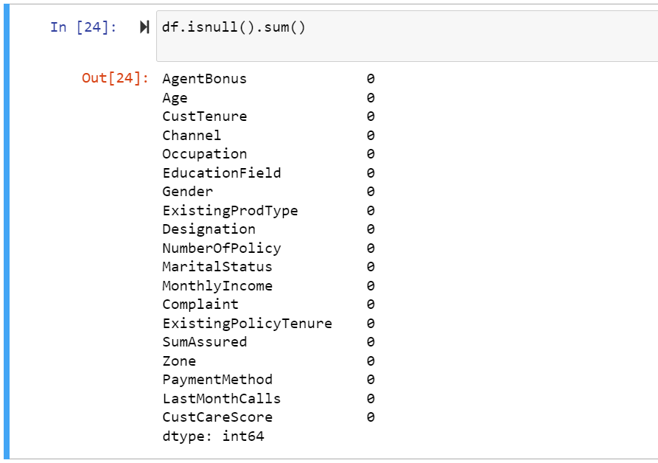

## Outlier treatment (if required)

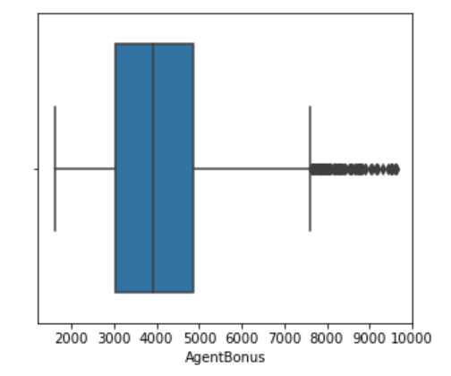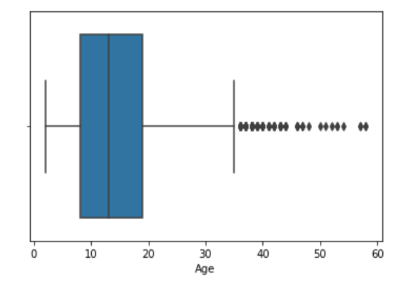

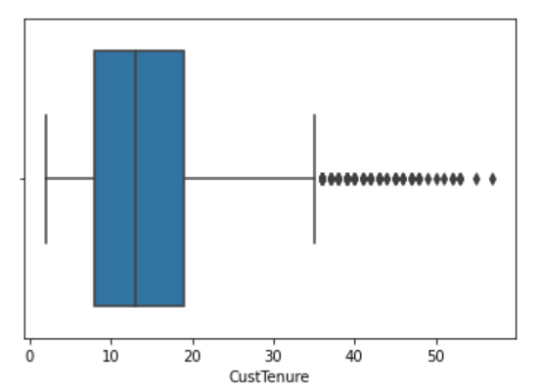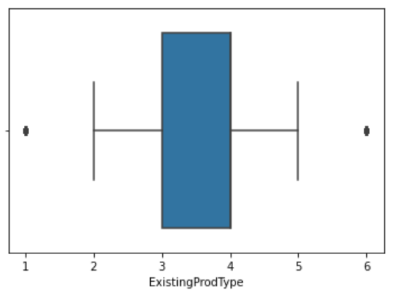

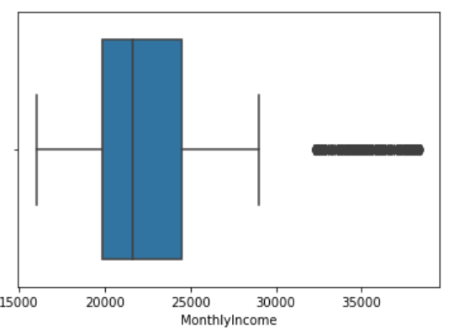 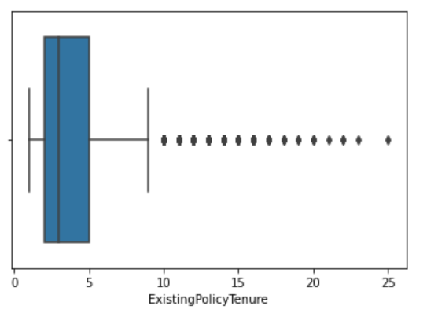

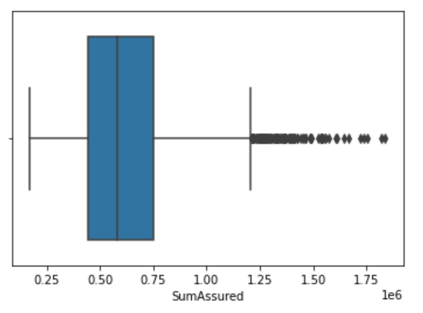 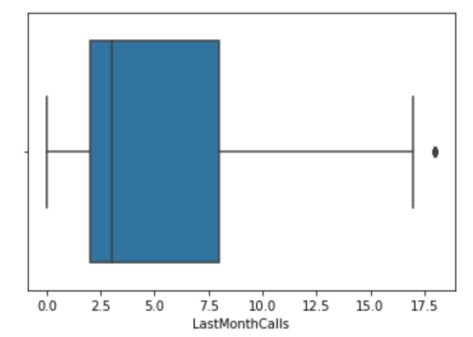

In a favour of doing any outlier treatment as most of the numeric data here has out of bound and hence the outliers might be able add value to the model . More so the numeric data which is continuous has huge outliers . Like the SumAssured or ExistingPolicy tenure has many observation which stands out and most of the others are in the right range.

**After fixing Outliars**:

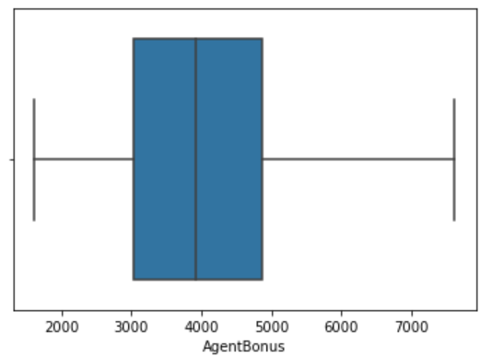 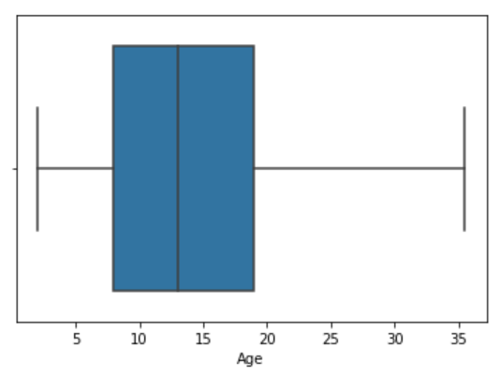

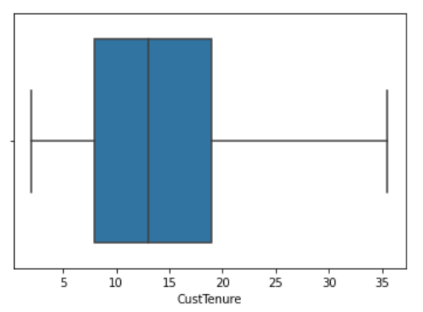 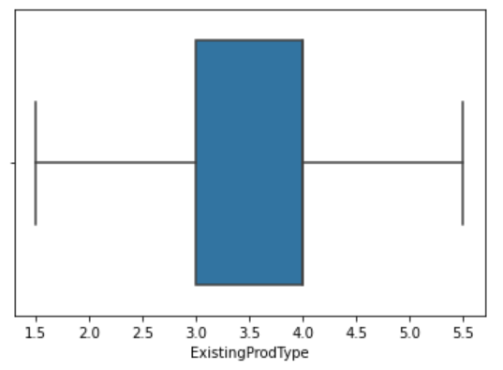

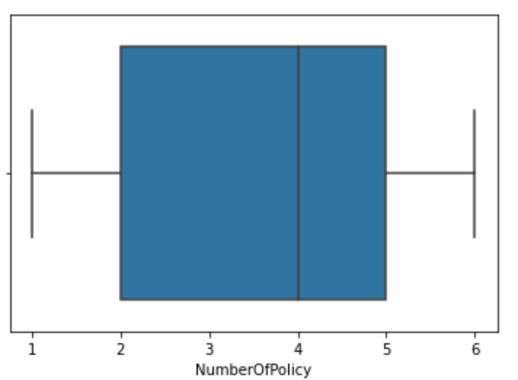 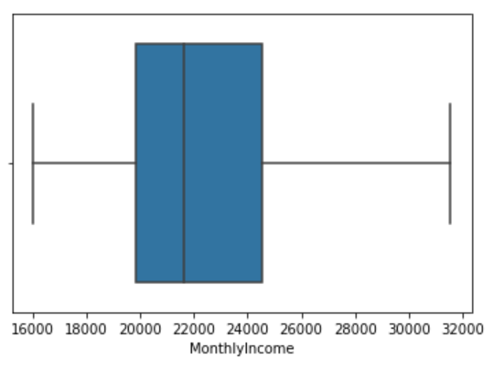

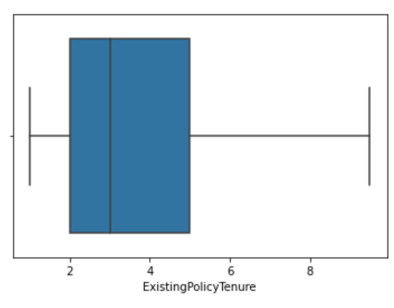 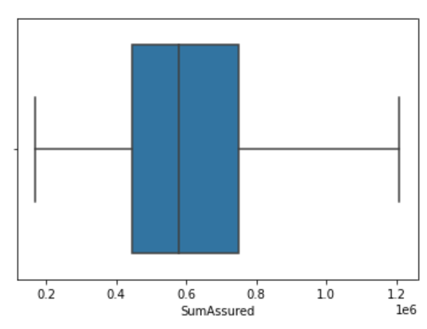

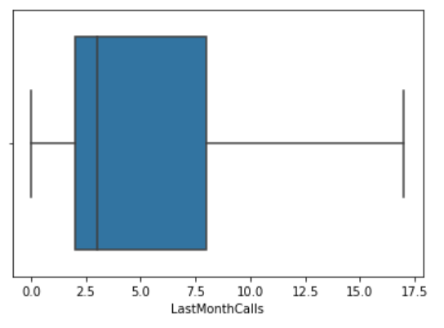 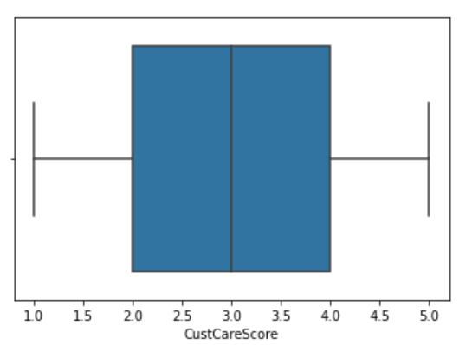

## Variable transformation (if applicable)

Channel : 3

Online 468

Third Party Partner 858

Agent 3194

Name: Channel, dtype: int64

Occupation : 5

Free Lancer 2

Laarge Business 153

Large Business 255

Small Business 1918

Salaried 2192

Name: Occupation, dtype: int64

EducationField : 7

MBA 74

UG 230

Post Graduate 252

Engineer 408

Diploma 496

Under Graduate 1190

Graduate 1870

Name: EducationField, dtype: int64

Gender : 3

Fe male 325

Female 1507

Male 2688

Name: Gender, dtype: int64

Designation : 6

Exe 127

VP 226

AVP 336

Senior Manager 676

Executive 1535

Manager 1620

Name: Designation, dtype: int64

MaritalStatus : 4

Unmarried 194

Divorced 804

Single 1254

Married 2268

Name: MaritalStatus, dtype: int64

Zone : 4

South 6

East 64

North 1884

West 2566

Name: Zone, dtype: int64

PaymentMethod : 4

Quarterly 76

Monthly 354

Yearly 1434

Half Yearly 2656

Name: PaymentMethod, dtype: int64

The highlighted data seems to be recorded incorrectly and required replacement and this was done to ensure the

right categories are picked up by the model

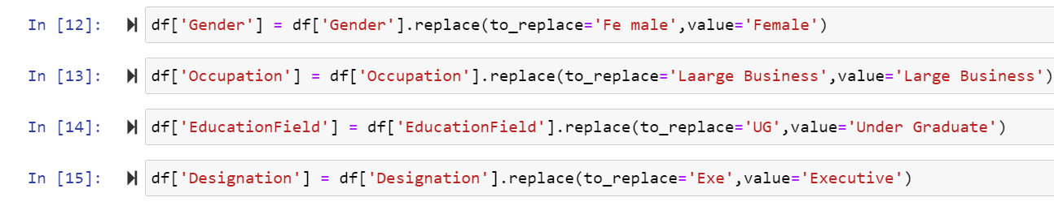

Since the complaint column had only values in 0’s and 1’s but was of numaric type .So we have converted it into categorical value.



**After fixing:**

Channel : 3

Online 468

Third Party Partner 858

Agent 3194

Name: Channel, dtype: int64

Occupation : 4

Free Lancer 2

Large Business 408

Small Business 1918

Salaried 2192

Name: Occupation, dtype: int64

EducationField : 6

MBA 74

Post Graduate 252

Engineer 408

Diploma 496

Under Graduate 1420

Graduate 1870

Name: EducationField, dtype: int64

Gender : 2

Female 1832

Male 2688

Name: Gender, dtype: int64

Designation : 5

VP 226

AVP 336

Senior Manager 676

Manager 1620

Executive 1662

Name: Designation, dtype: int64

MaritalStatus : 4

Unmarried 194

Divorced 804

Single 1254

Married 2268

Name: MaritalStatus, dtype: int64

Complaint : 2

1 1298

0 3222

Name: Complaint, dtype: int64

Zone : 4

South 6

East 64

North 1884

West 2566

Name: Zone, dtype: int64

PaymentMethod : 4

Quarterly 76

Monthly 354

Yearly 1434

Half Yearly 2656

Name: PaymentMethod, dtype: int64

## Addition of new variables (if required)



We have added a new column named Result where the value of the result column is high if the value of AgentBonous is grater than or equal to it’s mean else we put the value as low.

# Business Insights from EDA

## Is the data unbalanced? If so, what can be done? Please explain in the context of the business

low 2474

High 2046

Name: Result, dtype: int64

Data is balanced with almost equal High and low values. Thus it shows that nearly half of the agent are good performers.

## Any business insights using clustering (if applicable)



Variable plotted against Match Result

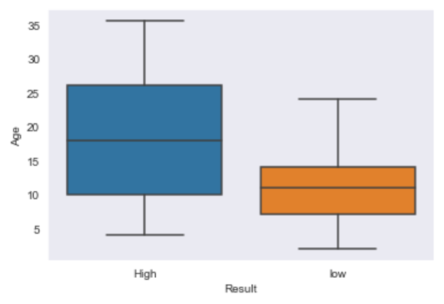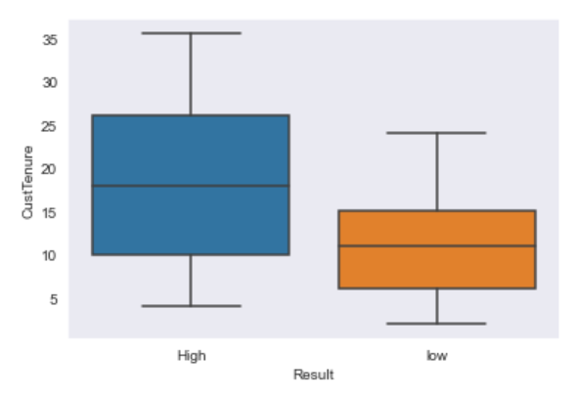

Young customer’s Agents have Lower performance

Longer customer tenure has better Agent performance.

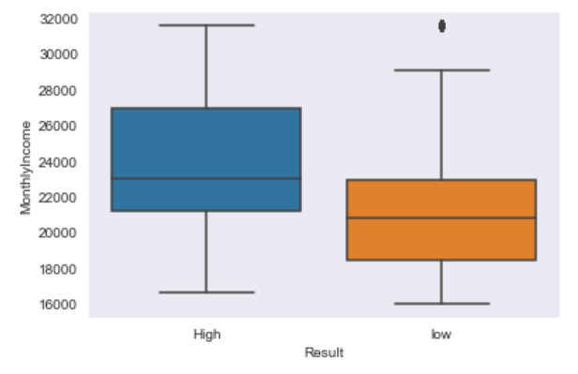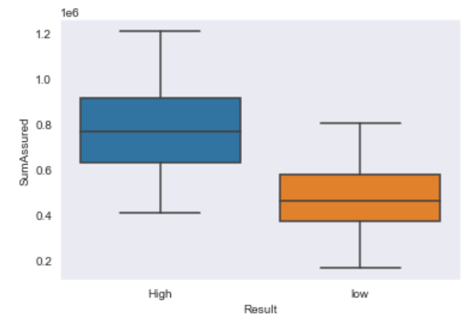

Young customer’s Agents have Lower performance

Higher Monthly Income results in better performance

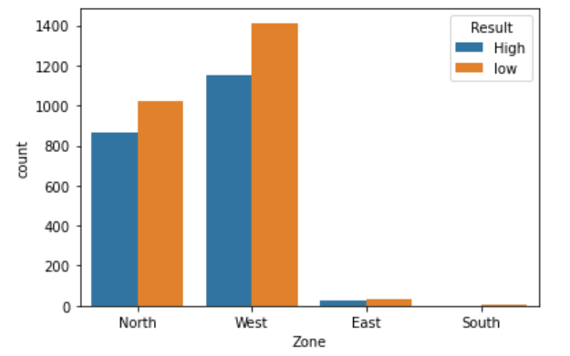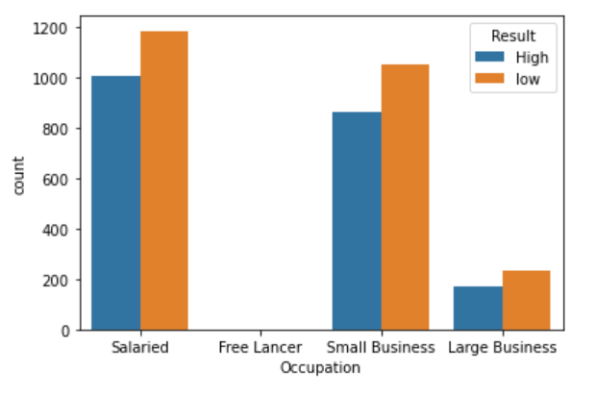

Most customers are salaried or have small business

Most customers are from North and West.

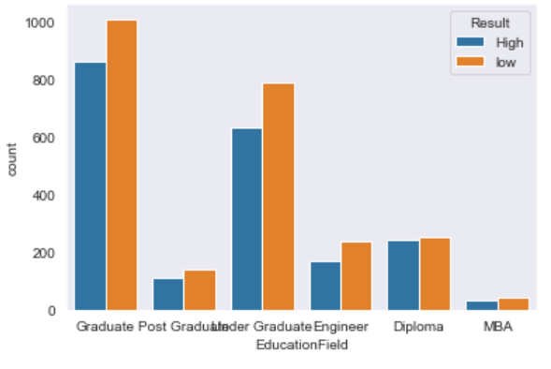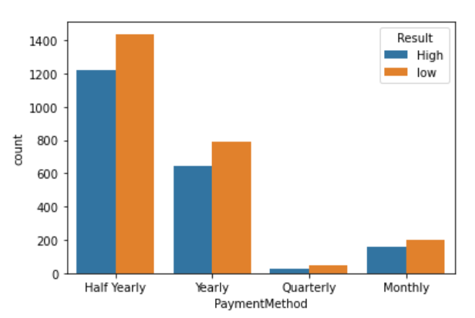

Most pay in half yearly.

Most customers are Graduate

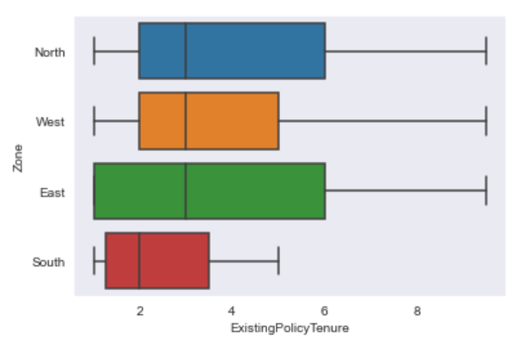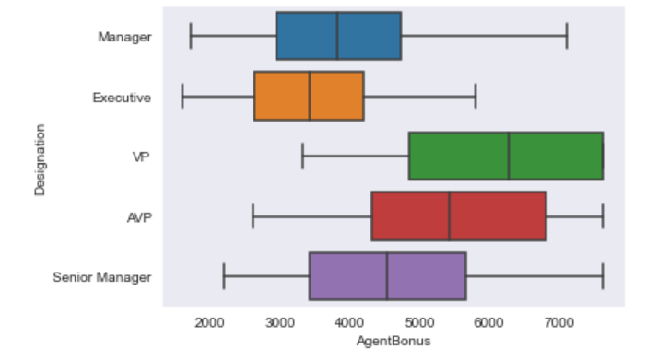

VP’s agents have highest bonus

East and North zone has highest customer tenures

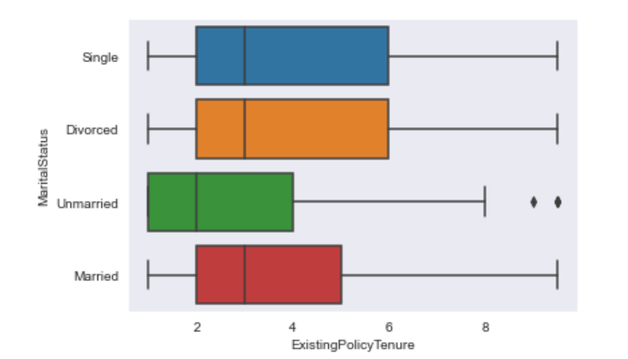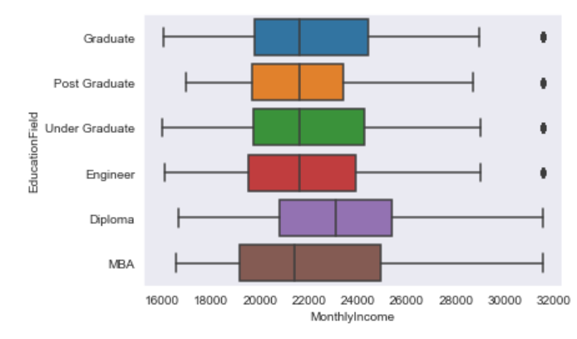

Single and Divorced have most existing policy tenure

Diploma monthly income is highest

## Any other business insights

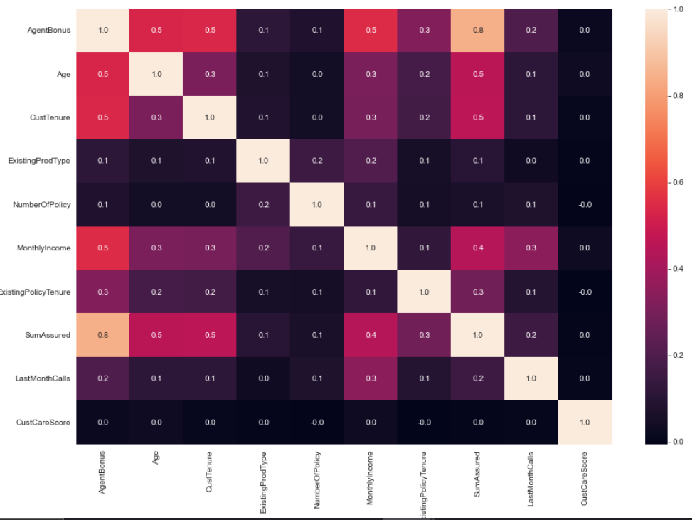

* Age is positively correlated with AgentBonus.
* Cust Tenure is positively correlated with AgentBonus.
* Monthly Income is positively correlated with AgentBonus.
* CustomerCareScore Does not affect any other column.
* NumberOfPolicy has very minimal effect on AgentBonus.